**PROJECT REPORT TEMPLEATE**

**VEHICLE MANAGEMENT SYSTEM USING SALESFORCE**

**TEAM ID:NM2023TMID19603**

**1.INTRODUCTION**

**1.1 Overview:**

A tracking software that captures location, movement, availability, activity, idle time, operator identity, and vehicle usage duration.

**1.2 Purpose**

* A vehicle management system is a software system or platform
* That serves to manage commercial fleets of vehicles, such as cars, vans or trucks or even heavy equipment .

**2. Problem Definition & Design Thinking**

An empathy map is a collaborative visualization used to articulate what we know about a particular type of user. If externalizes knowledge about users in order to

1. Create a shared understanding of user needs, and
2. Aid in decision making.

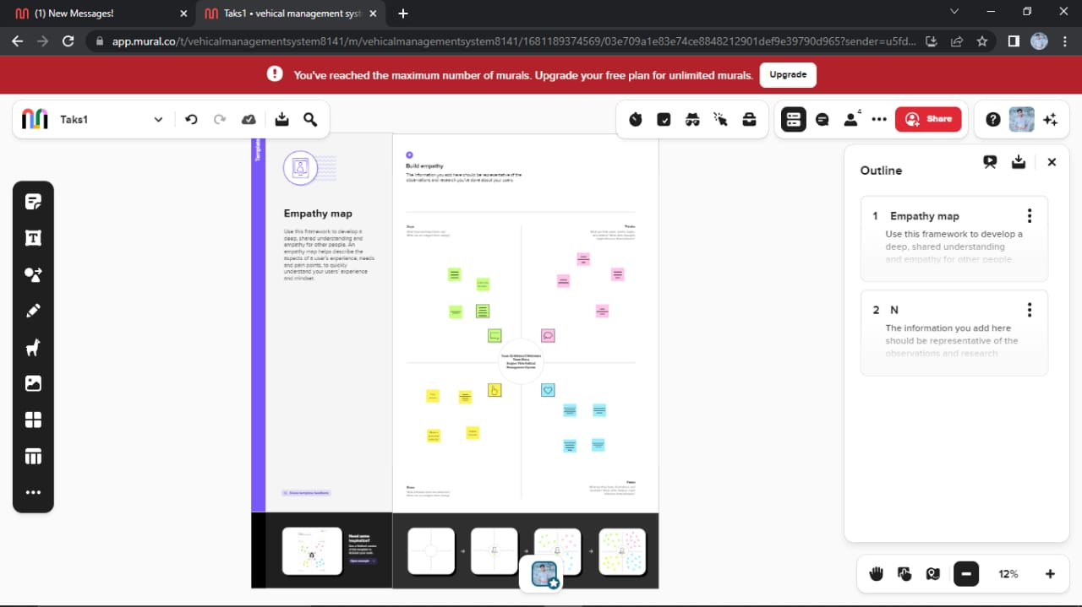

2.2 Brainstorming:

Brainstorming is a group problem-solving method that involves the spontaneous contribution of creative ideas and solutions. This technique requires intensive, freewheeling discussion in which every member of the group is encouraged to think aloud and suggest as many ideas as possible based on their diverse knowledge.

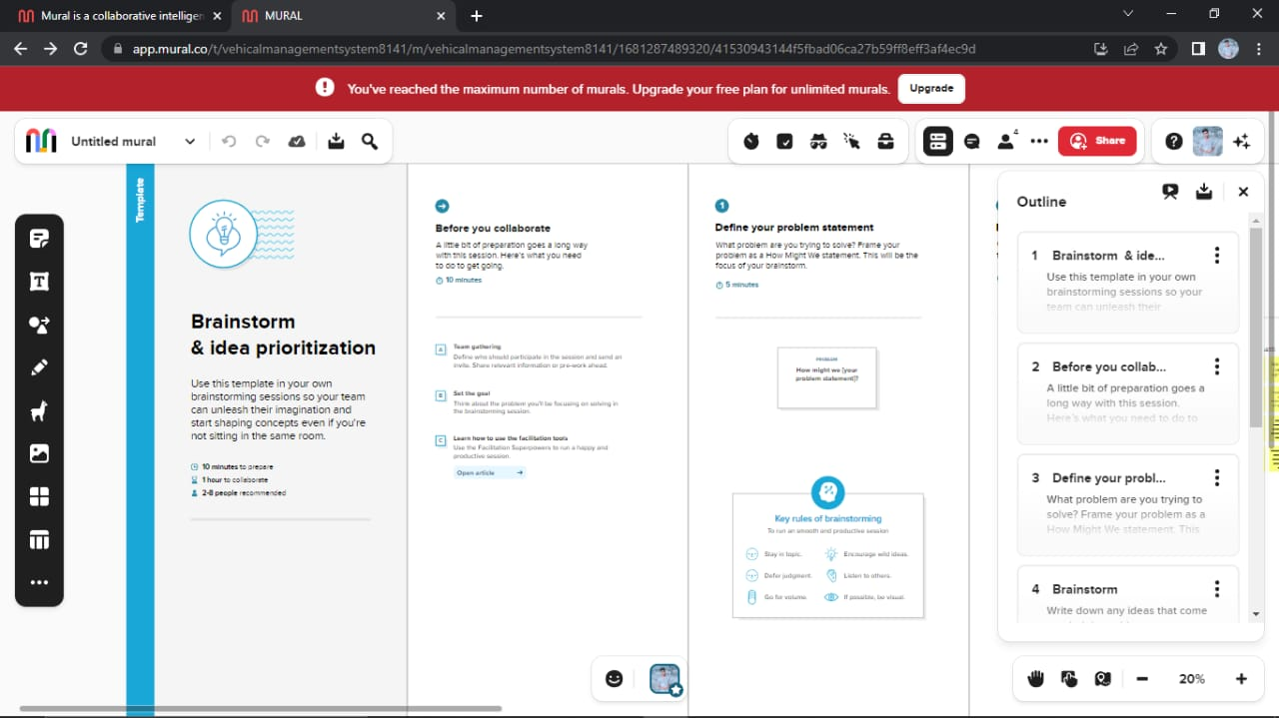

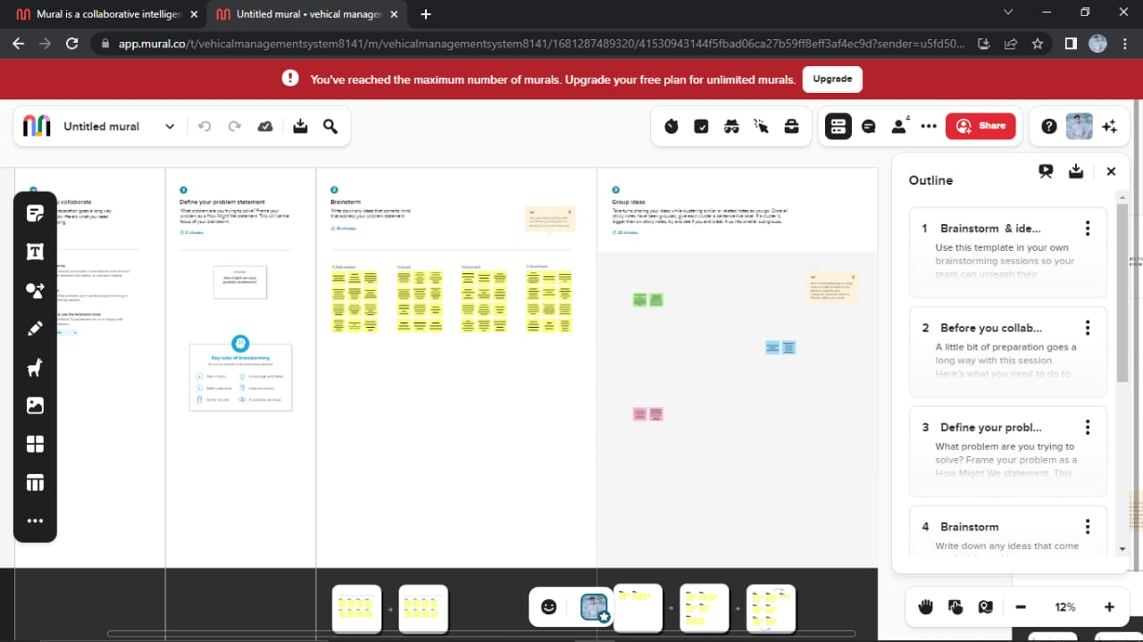

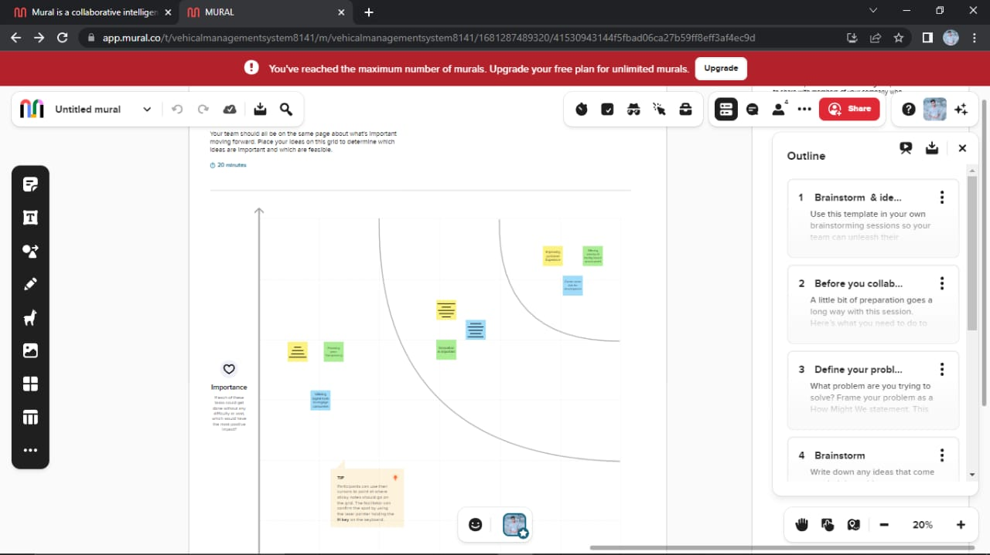

3. **RESULT**

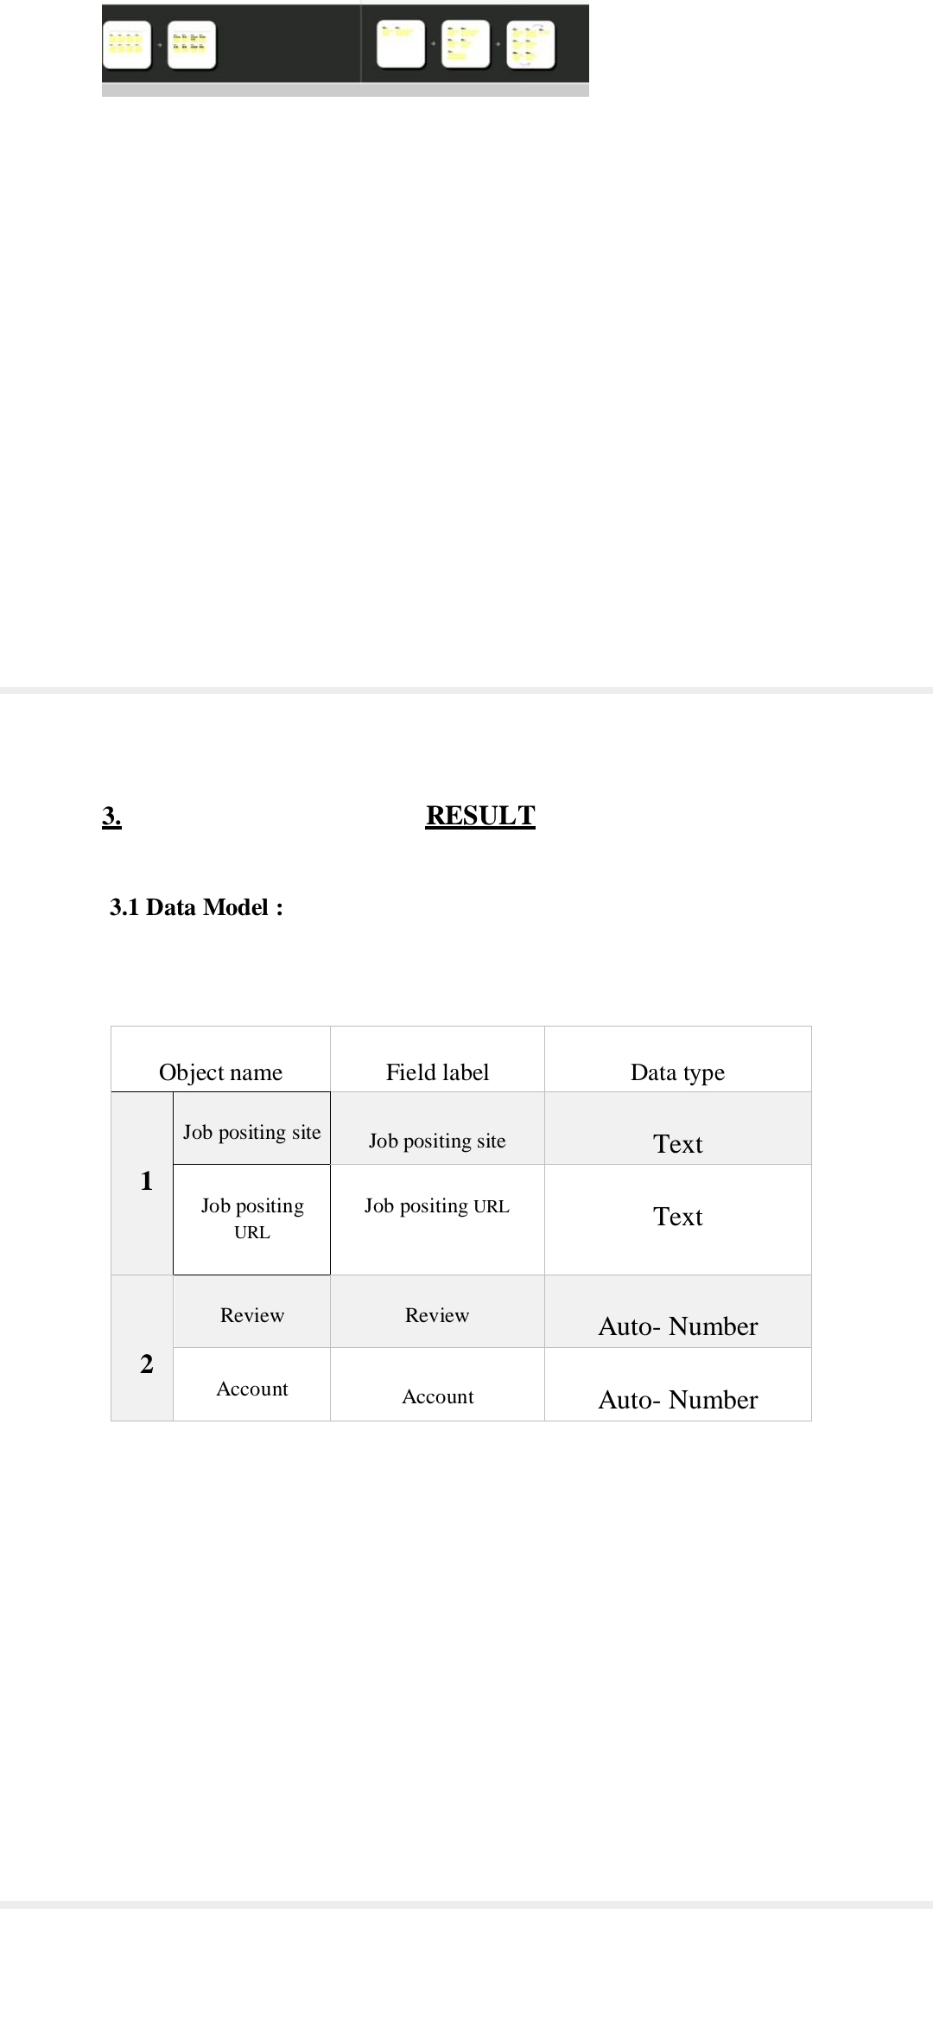

3.2 Activity & Screenshot:

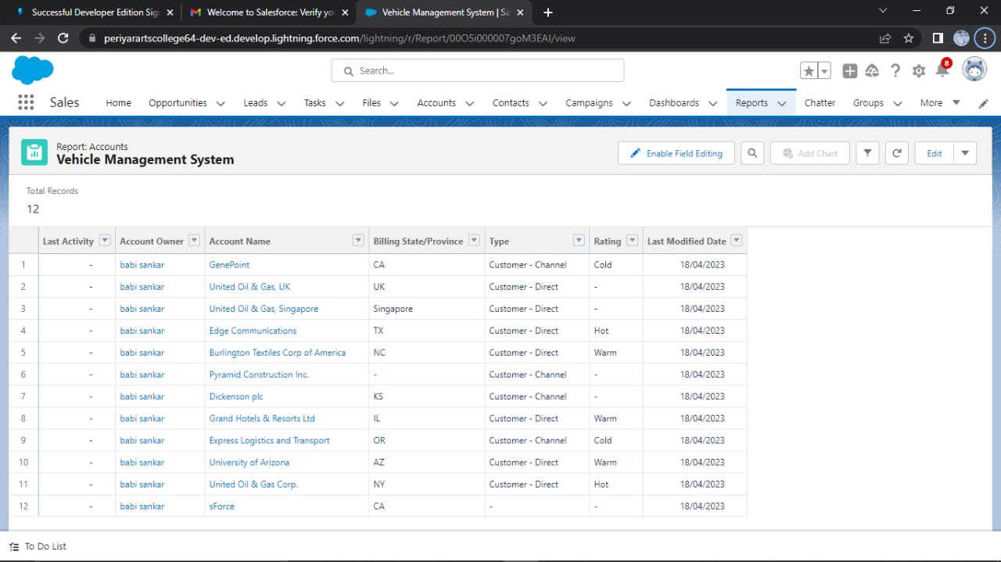

TRAILHEAD PROFILE PUBLIC URL

Team Leader - <https://trailblazer.me/id/bshankar53>

Team Member 1 - <https://trailblazer.me/id/ggowthami14>

Team Member 2 - <https://trailblazer.me/id/ggunal5>

Team Member 3 - <https://trailblazer.me/id/ggopi61>

Advantages:

* Accessing of vehicle documents becomes easy and time saving.
* Renewal of statutory documents on timely manner avoids any legal confrontation.
* No duplication ensures accuracy of vehicle data.

Disadvantages**:**

* They’re expensive to buy, maintain and insure.
* They emit air pollution that can harm your health.
* They contribute to global warming and climate change**.**

5. **APPLICATIONS**

* Complete database of customers.
* SMS alerts for service reminder.
* Promote Service Center.
* Maintain Service records.
* Customize the report according to business requirements.
* Develop operational expenditure model.
* GPS tracking.

**6. CONCLUSION**

Integrating database technologies in vehicle management systems is considered controversial by many. The general conception of database systems is that they are highly resource demanding both with respect to memory consumption and computational overhead.

**7.** **FUTURE SCOPE**

This project is a very scope in future. To assist in the tracking of vehicles operation and the planning of maintenance.